Optimal Sizing of Onsite Generation Resources for
Self-Sustainable Offshore Loads: Phase II
Abstract: The advancements in offshore renewable generation technologies have enabled the redesign of offshore power systems to utilize 100% clean energy, ensuring reliable power supply to offshore loads and accomplishing substantial CO2 emission reductions. Phase I of the project developed a cost optimization for renewable sizing (CORS) model, which optimizes the sizes of onsite energy resources to enable a clean energy-based offshore hybrid renewable energy system (OHRES) that can efficiently and reliably power offshore platforms. While Phase I yielded promising results, we identified four research gaps and potential extensions during its execution: (i) limitation of OHRES to power only a single platform, (ii) limitation of considering a single candidate product for each type of renewable resources, (iii) ignorance of solar and wind power generation performance degradation, and (iv) no models were established to enforce the energy resilience under single component failure scenarios and extreme weather scenarios. Phase II of the project will develop innovative modeling approaches to address those four research gaps, with the goal of powering offshore loads with clean renewable energy in a self-sustainable and reliable manner.

1. Background:
Offshore oil and gas (O&G) production plays a pivotal role in the energy landscape of many countries. In 2022, fossil fuels—petroleum, natural gas, and coal—accounted for 81% of U.S. primary energy production. Specifically, natural gas, petroleum and coal contributed 36%, 31% and 12% respectively to this energy mix. Globally, the energy industry is the largest contributor to carbon dioxide (CO₂) emissions, accounting for about 38% of CO₂ emissions. As of 2022, O&G operations contribute an equivalent of 5.1 billion tons of CO₂. Offshore O&G rigs in Texas, Louisiana, California, and Alaska are significant suppliers of the US’s oil and gas.
While existing power systems for offshore platforms rely on traditional diesel or gas generators, the advancements in offshore renewable generation technologies have enabled the redesign of rig power systems to utilize 100% clean energy, ensuring reliable offshore load supply and substantial CO₂ emission reductions. In the initial phase of this project sponsored by the Subsea Systems Institute (SSI), we designed an offshore hybrid renewable energy system (OHRES) with optimal sizes of selected resources to efficiently and reliably provide clean power to an offshore platform. To achieve this design, we created a cost optimization for renewable sizing (CORS) model and developed the associated CORS tool to optimize the capacities of generation and storage resources while minimizing overall lifetime costs for a single standalone offshore platform.

2. Overview of the Project in Phase I:
2.1. Completed Work:
Phase I of the project designed a clean energy-based OHRES system to efficiently and reliably power offshore platforms. When designing the OHRES system, we considered four types of offshore renewable energy subsystems, including offshore wind turbines, tidal energy converters, floating solar photovoltaic (PV) panels, and wave energy converters. In addition, we modeled two types of energy storage subsystems, including battery energy storage systems and hydrogen-based electrolyzer and fuel cell energy storage systems. After established the modularized component models for individual candidate resources, we integrated them into the proposed CORS co-optimization model to determine the best energy resource mix and optimal sizes/capacities of the selected energy resources for the OHRES system, aimed at minimizing the total cost of efficiently supplying electric power to an offshore platform over its lifetime.
For practical purposes, we utilized actual historical weather data, from repositories created by the National Data Buoy Center, National Oceanic and Atmospheric Administration, and National Renewable Energy Laboratory, to estimate the clean energy generators’ capacity factors. The capacity factor represents the ratio of the actual electrical energy output of a generating unit over a specific period of time to the maximum electrical energy output that could have been produced if the unit operated continuously at its full nameplate capacity during that same period. Fig. 1 illustrates the hourly average capacity factors of the four candidate offshore renewables, highlighting the energy procurement potential of each renewable energy technology in the Gulf of Mexico. It shows that under the same capacity, wind and solar power generators can produce much more than tidal and wave energy converters. This indicates wind and solar power are more suitable for the Gulf of Mexico.

Fig. 1. Hourly capacity factors for four offshore renewable generation in the Gulf of Mexico.
A salient and unique feature of the proposed CORS model is the consideration of all costs throughout the entire lifecycle of each candidate energy source, which include the pre-commissioning cost, capital cost, operations and maintenance cost, and decommissioning cost. The expected lifespan of each subsystem is also factored into the CORS model. We calculated the levelized cost of electricity (LCOE) for those renewable resources, which is listed in Fig. 2. LCOE is a widely-adopted measure of the average cost of generation of electricity from a generator over its lifetime, which can effectively quantify their competitiveness economically. The LCOE metric also indicates wind and solar power are preferred offshore renewables.
Offshore Renewable Clean Energy Technology | LCOE  in $/MWh
Wave Energy | 1,478
Tidal Energy | 12,283
Offshore Wind Power | 28.3
Floating Solar PV Power | 73.0

Fig. 2. The LCOE of four offshore
renewables in the Gulf of Mexico.
The key decision-making CORS model was developed to determine the optimal sizes of selected offshore renewables and energy storage resources. We implemented CORS in Python and designed a graphic-user interface (GUI) which will make it easier for engineers to use for their own platforms. Fig. 3 illustrates the initial GUI design for the proposed CORS model. With this GUI, it makes it much easier to use for engineers in the offshore energy industry. Another distinctive feature implemented for the OHRES system and energy source sizing procedure is the consideration and inclusion of battery degradation through innovative modeling enabled by machine learning technologies.

Fig. 3. Preliminary GUI design of the CORS tool.
We also performed time domain simulations and stability analysis under various scenarios to validate the effectiveness of the proposed OHRES system. Fig. 4 illustrates the associated time-domain simulation model that is implemented in MATLAB-Simulink. The Simulink model contains a solar PV subsystem and a wind turbine subsystem as well as a battery subsystem. The offshore wind turbine model takes in input of the number of wind turbines and the wind speed while the solar PV model takes into account the ambient temperature and the irradiance. Both the solar and wind power generation subsystems employ the maximum power point tracking technique that is to continuously allow them to operate at their maximum power production levels under various weather condition such as changing irradiation, temperature, and wind speeds. The time-domain simulation module can operate as predicted and generate accurate voltage and current curves as shown in Fig. 5. The model utilizes the battery energy storage subsystem as the source addressing power imbalance, serving to mitigate the intermittencies stemming from renewable resources.

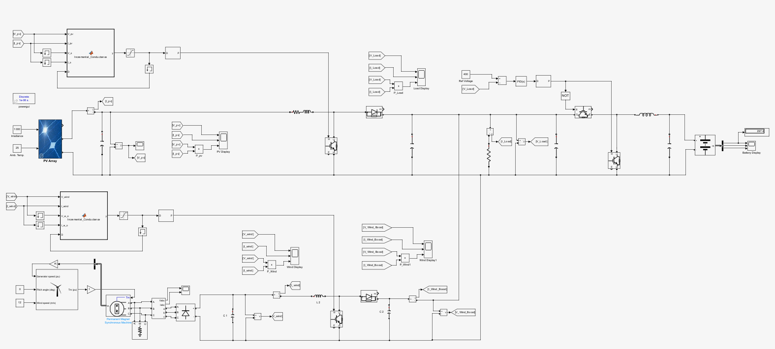
Offshore Wind Turbine Subsystem
Floating Solar PV Subsystem
Battery Energy Storage Subsystem
Fig. 4. Snapshot of the Simulink model of the OHRES system obtained from the CORS model.

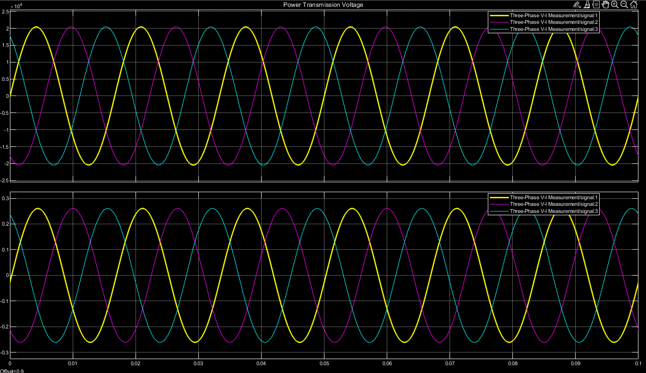
Fig. 5. Voltage and current waveforms of the designed OHRES system.

2.2. Key Findings:
Phase I of the project has made the following key observations and findings with respect to the Gulf of Mexico:
- Wind power is the most suitable and economically competitive offshore clean energy sources for application in the Gulf of Mexico, followed by the floating solar PV power.
- The capital cost for tidal energy converter is extremely high compared to solar and wind power. Irrespective of cost, even assuming 100% efficiency, tidal energy is not suitable since the tidal range is relatively small in the Gulf of Mexico.
- The capital cost for wave energy converter is also extremely high compared to solar and wind power. Assuming perfect efficiency, it will perform well in the Gulf of Mexico. However, when conversion efficiency is considered practically, it will no longer be economically feasible.
- Both battery and hydrogen storage subsystems, constrained by the space limitations on the offshore platforms, can effectively mitigate the offshore renewable energy generation uncertainty. Overall, battery is more suitable as hydrogen storage would often require larger space. When considering the degradation, the optimal battery size would decrease.
- When considering carbon credits, the designed OHRES system will be more economically competitive than existing power systems; and it will be preferable and practical to deploy clean energy to power offshore platforms over traditional diesel/gas generators.

2.3. Other Funding Opportunities and Achievements:
Based on the preliminary results of this project, we attempted to seek additional funding in relevant offshore energy areas including:
- One selected award, which is the Early-Career Research Fellowship (ECRF) in the Offshore Energy Safety track by the Gulf Research Program, provides $75,000 fund to Dr. Xingpeng Li who is the PI of this SSI project and $1,000 Honorarium to the mentor Dr. Kaushik Rajashekara who is the Co-PI of this project. This award is to support our research on enhancing the cyber security of offshore power systems.
- An attempted proposal was submitted to the Department of Defense’s Naval Surface Warfare Center, requesting $300,000 fund to develop planning and operation tools for the shipboard power systems.
- Two pending proposals, (i) one was submitted to the Gulf Research Program, requesting $1,000,000 fund to create multiple clean energy workforce development initiatives involving student training and education on offshore renewable energy and offshore power systems, and (ii) one was submitted to the Office of Naval Research, requesting $750,000 fund to develop a general security-constrained energy-assurance management framework for cyber-physical microgrid systems.
Dr. Li was named as an Emerging Leader by the Offshore Technology Conference. Of the nine honorees, he is the only one from an institution of higher education. The program selects young professionals with fewer than 10 years of experience in the offshore energy sector who demonstrate exceptional talents, commitment and promise as future leaders.

3. Team and Student Training:
The project team includes two senior personnel Dr. Li (PI) and Dr. Rajashekara (Co-PI). Dr. Li leads the Renewable energy-dominated future Power Grids (RPG Lab), which is part of the Power Electronics, Microgrids, and Subsea Electrical Systems Center (PEMSEC). Dr. Rajashekara is the Director of PEMSEC and Dr. Li is the Associate Director of PEMSEC. Fig. 6 shows two photos of the RPG Lab group, and Fig. 7 shows the PEMSEC group photo.

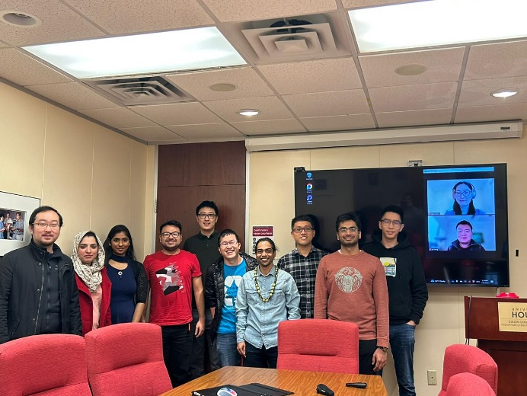
(a) Research meeting at a UH conference room. (b) Thanksgiving Party at the PI’s home.
Fig. 6. Group photos of the RPG Lab.

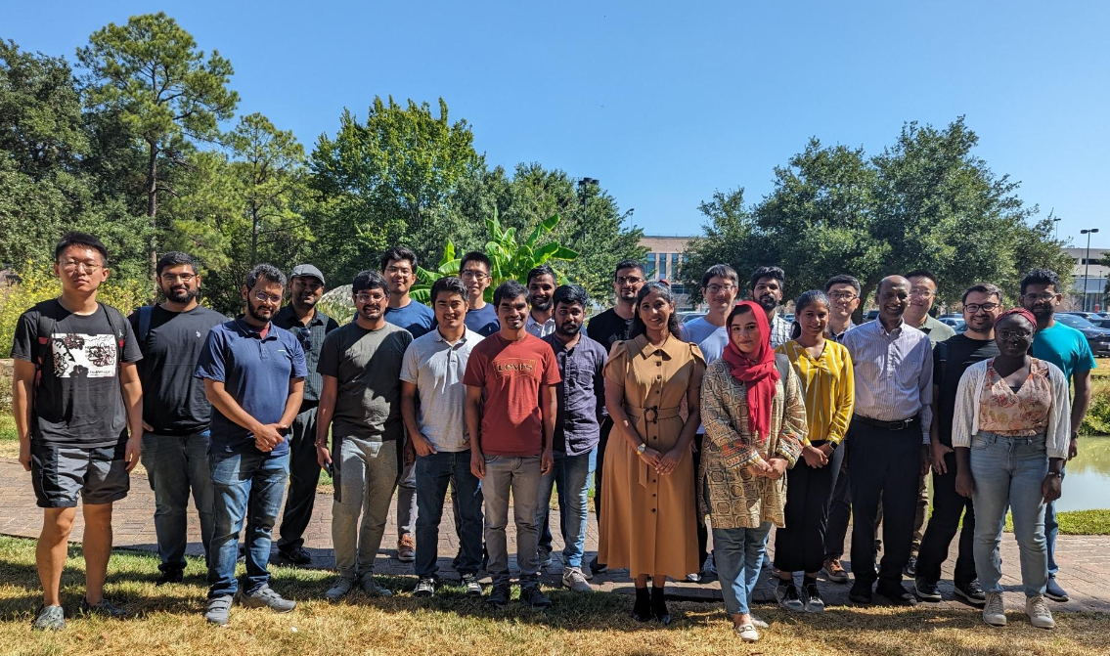
Fig. 7. Group photo of the PEMSEC center on the UH main campus.
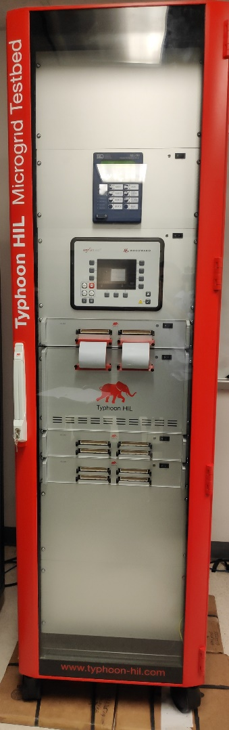
Fig. 8. Microgrid HIL testbed.
Our lab has a group of advanced facilities and equipment, including a hardware-in-the-loop (HIL) microgrid testbed as shown in Fig. 8. This microgrid testbed can integrate hardware components with a software-based simulation environment to conduct comprehensive tests, evaluate the performance of hardware components and dynamic behaviors of the overall system. Compared to a real testbed, HIL is cost-effective, safe and flexible. In addition, the PI has six high-end servers that provides the computing resources for this SSI project. Five of them are equipped with high-performance GPU cards. The PI also has licenses for many commercial power system software and optimization software.
With the support of this project, we are able to train three students and equip them with technical skills in the clean energy and offshore power system domain. They are introduced below. They all presented their research work at the Hydrogen Energy Symposium organized by UH Energy in April 2024, as shown in Figs. 9 and 10.
Ann Mary Toms was recruited as a new PhD student and research assistant at the University of Houston to work on this SSI project in January 2023. Since then, she has been working on this project for about one and a half years; and she is the main contributor implementing majority of the proposed research tasks. Particularly, she worked on modeling of individual offshore renewables and energy storage resources as well as the optimization CORS model. She developed programs in Python and also worked on the time-domain OHRES simulator in MATLAB. She will continue to conduct in-depth research in the offshore energy and offshore power system area, including the new research tasks for Phase II of this SSI project.
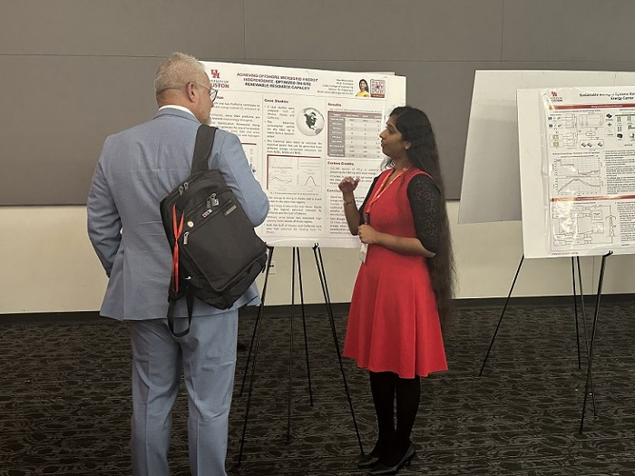
Fig. 9. PhD student Ann Mary Toms (right) was explaining her work at the Hydrogen Energy Symposium organized by UH Energy in April 2024.
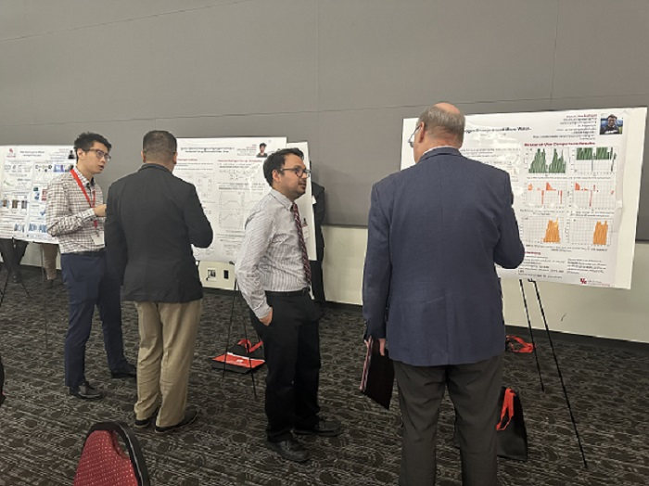
Fig. 10. Our PhD students Jin Lu (left 1) and Jesus Silva-Rodrigus (left 3) were explaining their research work at the Hydrogen Energy Symposium organized by UH Energy in April 2024.

Jesus Silva-Rodriguez is a fourth-year direct PhD student at the University of Houston. He was able to provide technical support and inputs to help implement the tasks for this SSI project such as the use of optimization solver and MATLAB-Simulink software. In the meanwhile, he was able to gain a deep understanding of offshore clean energy due to his involvement in this project. Before the expected graduation in December 2025, Jesus will continuously provide technical support to this project including Phase II tasks.
Jin Lu, a fourth-year PhD student at the University of Houston. His expertise includes power system optimization and operations, coordination of the hybrid power and hydrogen energy systems. He was able to read and understand the source codes implementing the proposed models, and then contributed to this SSI project by developing the GUI tool in the Python environment. With his efforts on this project, Jin has been well trained in the offshore power system area. He will be completing his PhD program in the summer of 2024, and will join a clean energy company focusing on the development and grid integration of solar farms.
The research we conducted for Phase I of this project has led to a peer-reviewed publication; and we are currently preparing to write a second journal paper. In addition, with the experience and knowledge gained from this SSI project, we were able to come up with a commercialization idea and attend the UH Energy Innovation Competition in both 2023 and 2024.

4. Research Gaps and Extensions:
While Phase I yielded promising results, we identified four significant research gaps during its execution. These gaps are summarized below, which will be addressed in Phase II.
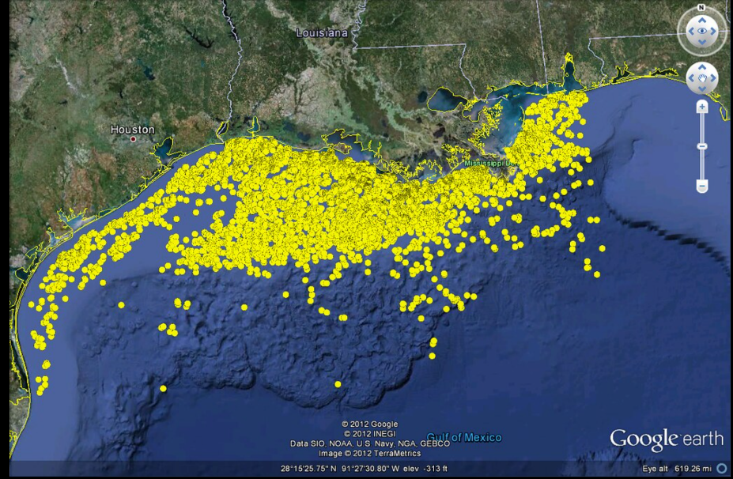
Fig. 11. The Oil and Gas Platforms in the Gulf of Mexico as of 2012. [Photo credit: The National Academies Press]
- Phase I of the project focused on designing the optimal OHRES for a single offshore platform. However, in the Gulf of Mexico, many platforms are located very close to each other, as shown in Fig. 11. Thus, it would be more practical and economic to design a centralized OHRES that supplies power to a cluster of O&G platforms located in close proximity. This approach will improve the system efficiency and achieve cost reduction, as well as increase system reliability and resilience.
- In Phase I of the project, the offshore renewable energy generators considered for the OHRES were restricted to a single product with a fixed power rating. Instead of restricting the consideration to a single product per resource type with a fixed power capacity, it is more advantageous to explore a mix of products offering different configurations and power ratings within each resource type.
- While we modeled usage-based battery degradation in Phase I, the performance decline of the most effective offshore renewable resources, offshore wind and solar power, was not considered. It is known that solar panels and wind turbines are found to lose some amounts of output power per year. Such asset degradation will not only lead to extra capital cost for resource replacement but also reduce the system generation adequacy, which should be factored into the planning CORS model to optimally size the onsite generation resources for OHRES.
- A power system like the OHRES achieves N-1 security when it can continue its normal operations reliably despite the unexpected failure of any single critical component such as a generator. This system reliably standard is crucial for enhancing OHRES reliability and redundancy, which was not addressed in Phase I. Additionally, energy resilience constraints during extreme events have not yet been considered. Both N-1 reliability requirements under the single component failure scenarios and energy resilience requirements under extreme weather scenarios will need to established and considered in the OHRES design for practical purposes, which will be explored in Phase II.

5. Proposed Work for Phase II:
5.1. Research Plan:
Phase II of the project will develop innovative modeling approaches to determine the optimal sizes of selected offshore energy sources for the enhanced centralized OHRES that can effectively supply continuous power to multiple O&G platforms located in close proximity, with the goal of powering offshore loads with clean renewable energy in a self-sustainable and reliable manner. The proposed enhanced OHRES is illustrated in Fig. 12. Wave energy converters and tidal energy converters are not included since they are much less efficient and much more expensive than wind/solar power in the Gulf of Mexico per the findings in Phase I. Phase II of the project consists of five cohesive new tasks. They are briefly explained below.

Task 1: Multi-Platform Modeling
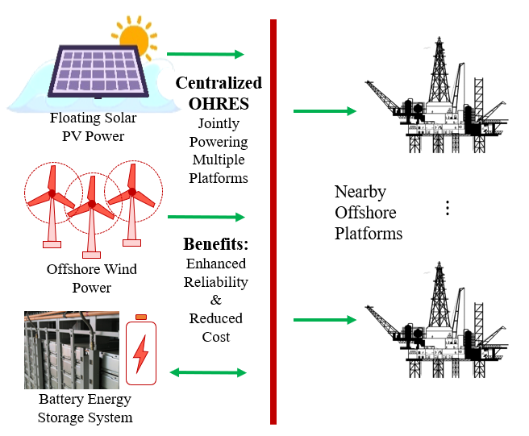
Fig. 12. Illustration of the enhanced OHRES for powering multiple nearby offshore platforms.
This task will address the first gap identified in the above section. Initially, the OHRES was sized to support a single O&G platform; however, as shown in Fig. 11, it illustrates the proximity of O&G platforms in the Gulf of Mexico. In this task, we will consider multiple platforms located in close proximity as a single cluster when optimally sizing onsite energy resources that supply electricity through an enhanced centralized OHRES with interconnected power cables. The major factors influencing the decision-making model include the exact locations and electrical demand profiles of nearby platforms that share the same power supply system. We will first calculate the distance between each pair of two platforms and then estimate the cable length and parameters such as impedance. Subsequently, we will determine the optimal cable connection topology and then estimate the electricity loss factors on those cables. Finally, an enhanced but generic CORS model for designing multi-platform OHRES, referred to as CORS-MP, will be developed, which can consider the power delivery losses among different platforms. Comparative analysis will be conducted to quantify the economic benefits of a centralized large-scale OHRES compared to multiple small-scale OHRES designed separately for individual offshore platforms.

Task 2: Inclusion of Multi-Candidate Offshore Renewables with Flexible Capacities
This task will bridge the second gap identified in Section 4. We will conduct comprehensive literature review and offshore energy market analysis to compile two lists of available candidates for offshore wind turbines and floating solar PV panels respectively. While considering a single candidate product with fixed capacity per each type of renewables will minimize the computational complexity of the CORS model, it will lead to suboptimal solutions and create biases in terms of which commercial product should be selected as the only candidate when designing the OHRES. In this task, we will develop an enhanced CORS model that can consider multiple candidates for the same type of offshore renewables, referred to as CORS-MC. The proposed CORS-MC will be able to consider products from different market players and determine the best combination of different types of resources as well as the candidates from the same type of resources. This task will diversify the selection of candidate resources and their generation technologies. Cost-benefit analysis will be performed for the proposed CORS-MC model with multiple candidate offshore renewables, compared to the results obtained with different benchmark CORS models considering single candidates with fixed power ratings.

Task 3: Modeling of Asset Degradation Characteristics
A salient and innovative feature of this task is the modeling of renewable energy generation asset degradation characteristics including time-based efficiency reduction for solar panels and wind turbines, in addition to the usage-based battery energy capacity reduction that was studied in Phase I. This task will address the third gap identified in Section 4. For solar PV panels, the degradation is in terms of energy conversion efficiency reduction, which is affected by multiple factors including UV exposure, thermal cycling and humidity. The annual PV degradation is around 1%, which is very substantial and should be considered for planning studies. Similarly, wind turbines are observed to lose about 1.6% of their output power per year; the degradation could reduce wind power generation by more than 10% in 20 years, increasing the LCOE by about 10%. In this task, we will create formulations to reflect such asset performance degradation characteristics and then seamlessly integrate these degradation models into the decision-making engines CORS, referred to as CORS-AD, for the OHRES planning application. We will consider the degradation feature of both solar and wind power generating assets to ensure there will be sufficient energy to power the offshore platform throughout the entire OHRES lifespan including the last few years when assets have greatly degraded. We will evaluate the benchmark CORS solutions, that do not capture renewable asset degradation, in practical scenarios where renewable asset do degrade, which can show the superiority of the proposed enhanced CORS-AD model.

Task 4: Enhancement of the System Reliability and Resilience
While economic performance is a key evaluation factor, system reliability and resilience are essential to the operations and survivability of offshore platforms. This is particular important for the Gulf of Mexico during the active hurricane seasons. In this task, we will address the fourth gap identified in Section 4, by enforcing the N-1 reliability and energy resilience requirements. It is not uncommon that a particular unit is offline due to unexpected failure or expected maintenance; under such situations, we require the OHRES to survive and supply continuous power to offshore loads. This will be achieved by creating N-1 operation scenarios and then enforce sufficient capacity requirement to be met by the remaining resources, implemented as additional constraints in CORS. In addition, under some rare extreme weather events where particular offshore renewables do not produce as much as normal situations for an extended period of time, the designed OHRES should still be able to meet a subset of the critical loads. This will be enforced by developing a resilience metric, minimum time of uninterrupted power supply to critical loads following the start of the event, and establish constraints to ensure sufficient energy meeting critical load for at least that minimum amount of time. The enhanced model is referred to as CORS-RR. Comparison will be made between CORS and CORS-RR, which can quantify the enhanced system reliability and resilience.

Task 5: Development of the Integrated CORS Model and Open-Source Tool
This task will consolidate the solutions addressing the aforementioned four gaps in the above four tasks respectively, and develop an integrated CORS model (I-CORS) that combines the salient and unique features of the four models CORS-MP, CORS-MC, CORS-AD, and CORS-RR. Cost-benefit analysis will be conducted to show the marginal benefit of each feature. In I-CORS, renewable curtailment will be modeled, which is to avoid infeasibility or unnecessary investment on the battery storage subsystem due to occasional excess renewable generation. Overall, the proposed comprehensive I-CORS model will provide quality solutions that can not only provide economic gains but also enhance the system reliability and resilience. In addition, we will extend our open-source tool developed in Phase I by incorporating the new features and tasks developed in Phase II.

5.2. Project Deliverable Schedule:
Phase II of the project consists of five cohesive tasks. It is anticipated to complete them in 18 months. The project Gantt chart in Table I shows the timeline for the proposed work. We will submit 5 progress reports and 1 final report per the reporting requirements.
Table I: Project Gantt Chart
Tasks | Quarters
Tasks | 1 | 2 | 3 | 4 | 5 | 6
Task 1: Modeling of Multiple Nearby Platforms
Task 2: Modeling of Multiple Renewable Candidates
Task 3: Modeling of Asset Degradation Characteristics
Task 4: Enhancement of the System Reliability and Resilience
Task 5: Development of the I-CORS Model and the Associated Tool

5.3. Contributions and Uniqueness:
The contributions and uniqueness of this project are summarized as follows:
- Existing studies often focus on individual platforms and overlook the potential economic and reliability benefits provided by an interconnected OHRES. This will be investigated in Phase II. Another improper assumption is the limitation of a single candidate product for each type of renewable resource, which will be removed in this project for model enhancement and practical purposes.
- This project will consider important asset degradation factors that are ignored in existing power system design and operation studies. These factors include age-related performance degradation for some assets such as solar panels and wind turbines (for Phase II), and usage-based capacity degradation for other assets mainly battery cells (completed in Phase I). In Phase II of this project, we will model and consider the age-related renewable power generation degradation in OHRES energy planning and optimal resource sizing.
- Energy reliability and resilience are important for many facilities including offshore platforms. Studies on defining universal energy resilience requirements are still limited. This project will contribute to this aspect by developing two sets of novel constraints: (i) reliability constraints for single-component failure situations, and (ii) emergent resilient constraints for emergent situations such as extreme weather events.
- Costs are also important factors to consider by offshore platform owners and operators. Majority existing efforts mainly focus on capital cost and operation cost, while other cost factors are ignored but must be considered by the industry for real-world implementations. In Phase I, we considered all costs throughout the expected asset lifetime including the pre-commissioning cost, capital cost, operation and maintenance costs, replacement and decommissioning cost. We will continue to consider the asset lifetime cost in Phase II.

5.4. Impact and Significance:
This project will leverage onsite generation resources including renewable resources to ensure energy reliability and resilience with the least cost to power offshore platforms. The proposed I-CORS model will provide optimal solutions to support the decision-making for long-term energy planning for designing the best OHRES. Various possible extreme scenarios like extended period without any wind and N-1 scenarios like sudden loss of an onsite resource will be modeled and considered in the I-CORS model to improve the energy reliability and resilience. The developed tool that will be made publicly available can greatly support power system engineers to make optimal decisions to ensure energy security for offshore loads. The success of this project will substantially promote clean energy and offshore renewables.

