Historically Underutilized Businesses (HUB/VetHUB)
HUB/VetHUB Overview
- VetHUB is Veteran Heroes United in Business. The program will focus on certification of service-disabled veterans (SDV) to facilitate their growth and development and increase HUB contracts and subcontracts with the state of Texas.
- The Historically Underutilized Business (HUB) program at the University of Houston is administered in accordance with the Texas Government Code Chapter 2161 and Texas Administrative Code, Title 34, Part 1, Chapter 20, Subchapter D, Division 1.
HUB Subcontracting Plan (HSP)
- The Texas Government Code 2161.252 (b) requires the Subcontracting Plan for contracts of $100K or more where subcontracting is likely
- In accordance with the Texas Administrative Code Section 20.285, UH takes the following steps to determine the HUB subcontracting probability:
    - Examine the scope of work to be performed under the proposed contract and determine if it is likely that some of the work may be performed by a subcontractor;
    - Check the HUB directory for HUBs that may be available to perform the contract work; and
    - Consider whether subcontracting is probable for only a subset of the work expected to be performed or the funds to be expended under the contract.

UH Role in HSP Review
- The University of Houston reviews HUB Subcontracting Plans for administrative completeness and compliance with applicable state requirements. UH’s review is limited to determining whether the HSP has been properly completed in accordance with Comptroller rules and procurement requirements.
- UH does not approve or guarantee subcontracting outcomes, nor does review of an HSP constitute a determination that proposed HUB participation percentages will be achieved.
HSP Information
- UH provides guidance to the prime contractors on how to complete the HSP form (See our training slides).
- UH utilizes the software B2G to maintain the HUB sub-contractor payments by prime contractors.
  - The UH HUB department will set prime contractors in the B2G system.
  - Once set up in the system, the prime contractor will receive a notification e-mail from B2G including the instructions on how to log in.
  - Prime contractors are required to report their subcontractor payments in the system.
  - B2G provides training sessions to guide the prime contractors after the contracts are awarded to make sure that they follow the process and report their subcontractor payments. Once set up in the system, the prime contractor will receive a notification e-mail from B2G including the instructions on how to log in.
  - After logging in, click on “Training Videos in the Video Library” to see video training sessions including system navigation and step-by-step instructions.

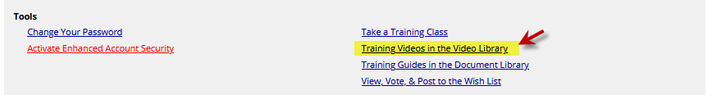

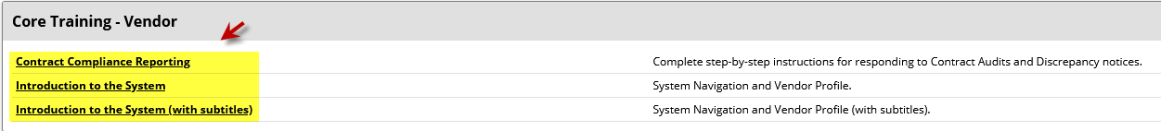

- The prime contractors are responsible for entering the subcontractor payments promptly. UH HUB monitors the database and communicates any underperformance to the applicable prime contractors to ensure that they complete their contracts in accordance with their HUB Subcontracting plan. If the prime contractors failed to implement the HUB subcontracting plan in good faith, UH may bar the contractors from further contracting opportunities per Texas Government Code 2161.253.
HUB Reports
- The UHS/UH HUB Reports can be viewed on the Comptroller’s website under Section VII. State Agency Expenditure Data.
Contact Tamika Tatum at (713) 743-4283 (UH HUB Department) hubdocs@Central.UH.EDU for additional information.

