How to run reports for outstanding Travel Card Transactions

Note: Only a limited number of people have access to run these reports. At least one person in each college/division has been given access.

You can run the following Concur Reports to identify outstanding Travel Card transactions:

Travel Card Transactions – No Expense Reports created
This report will generate a list of Travel Card Transactions that are not assigned to any Expense Reports.

Travel Card Transactions – Expense Reports created but not approved by AP
This report will generate a list of Travel Card transactions that are assigned to Expense Reports, but the Expense Reports are not approved by Accounts Payable yet.

- From the Concur home page under Reporting, click on Intelligence



- Click on Team Content > then click on University of Houston System

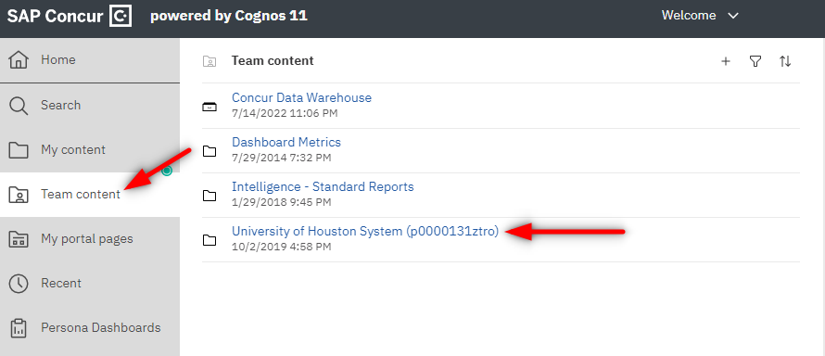

- Open folder User Reports

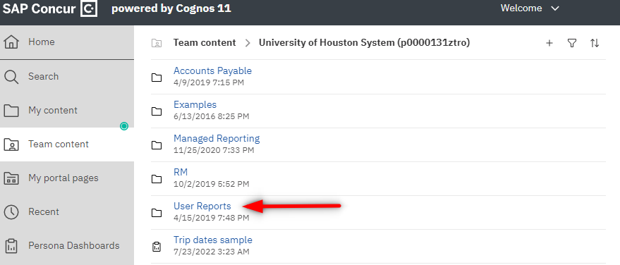

- Click on “Travel Card Transactions – No Expense Reports created” to see outstanding Travel Card transactions that are not assigned to Expense Reports. Click on “Travel Card Transactions – Expense Reports created but not approved by AP” to see outstanding Travel Card transactions which Expense Reports need AP approval.

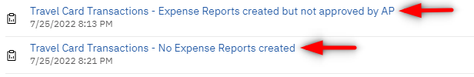

- From the report, click on the Run as  icon, then click on Run Excel in order to run the report in Excel

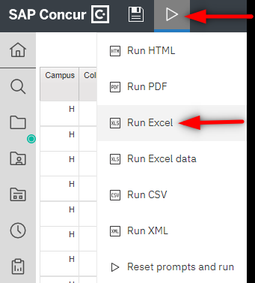

Note: Concur Reports pulls the information as of the previous day. Therefore, if you run the above reports today, you will see the results listed as of yesterday.

