How to run reports for outstanding Travel Requests and Expense Reports

Note: Only a limited number of people have access to run these reports. At least one person in each college/division has been given access.

- From the Concur home page under Reporting, click on Intelligence

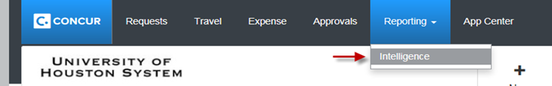

- Click on Team Content, then click on University of Houston System

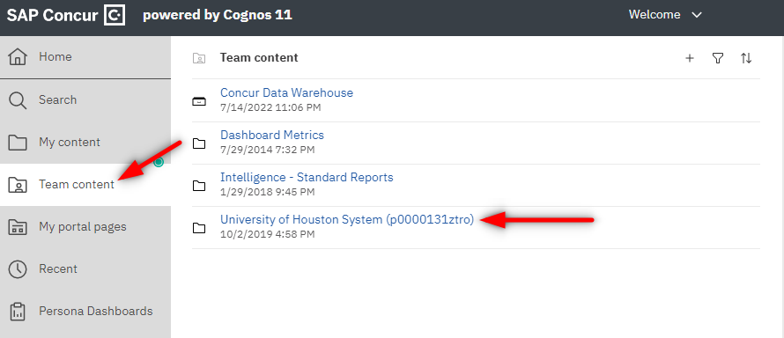

- Open folder User Reports

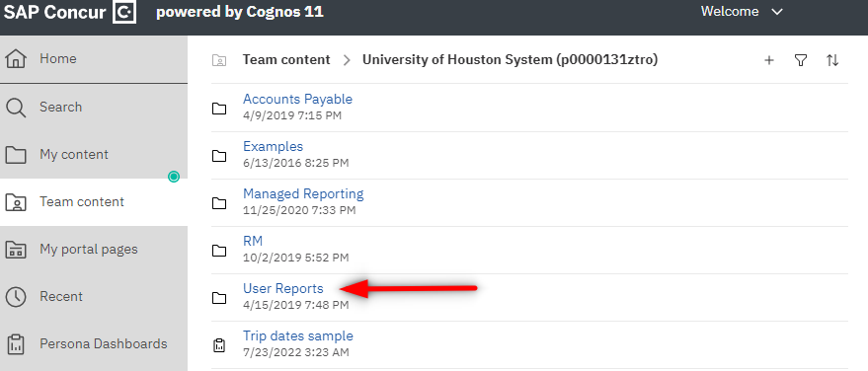
- You can choose either Outstanding Expense Reports or Outstanding Travel Requests.

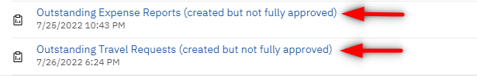

- From the report, click on the Run as  icon, then click on Run Excel in order to run the report in Excel

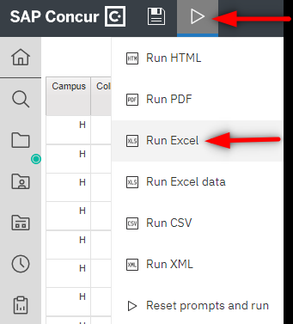

Note: Concur Reports pulls the information as of the previous day. Therefore, if you run the above reports today, you will see the results listed as of yesterday.

