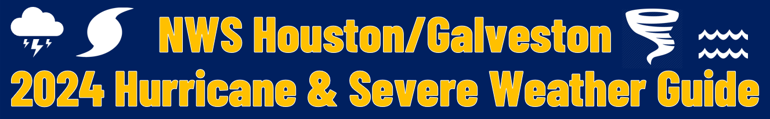

Download the 2024 Hurricane and Severe Weather Guide
from the National Weather Service Houston/Galveston.
ENGLISH SPANISH

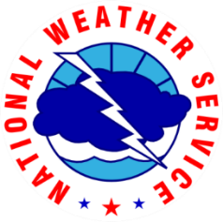
NATIONAL WEATHER SERVICE
HOUSTON/GALVESTON | weather.gov/houston

