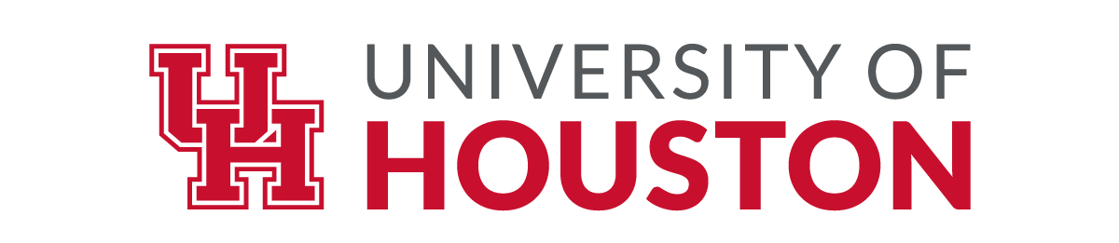

Honorary Doctoral Degree Recipients

An honorary degree is the highest honor a university can bestow.
The following individuals have been recipients of Doctor of Humane Letters degrees, honoris causa, for exemplary service to the University of Houston or society at large.

1938
Special Honorary Law Degree
Hugh Roy Cullen and Lillie Cranz Cullen

1950
Special Honorary Degree
Edison E. Oberholtzer

1980
Special Honorary Degree
The Honorable Aaron J. Farfel

1984
George P. Mitchell
The Honorable Oveta Culp Hobby

1985
Gerald D. Griffin*
George A. Butler

1986
William Barron Hilton
Philip C. Johnson

1987
LeRoy and Lucile B. Melcher
Philip G. Hoffman

1988
Wilhelmina Cullen Robertson

1989
The Honorable Robert A. Mosbacher
Aaron Cohen

1990
Donald Barthelme**
Norman J. Ramsey

1991
Faith P. Bybee
Christoph Eschenbach
Eric M. Hilton
The Honorable Catalina Vasquez Villalpando
His Excellency Rafael Angel Calderon Fournier*

1992
Jacques-Louis Lions
Gurji Ivanovich Marchuk
David Gockley

1993
Luis Garibay
Reverend William A. Lawson

1994
The Honorable George H. W. Bush
Daniel Howard Yergin
Ron Stone

1995
The Honorable John J. Moores
Veronica Nia Dorian Becnel**
His Excellency Carlos Saul Menem*

1996
Ernesto J. Cortes, Jr.
Song Jian*

1997
Edward Franklin Albee
Glenn Allan Goerke
The Honorable William P. Hobby, Jr.

1998
The Honorable Robert C. Lanier
The Honorable Kenneth L. Lay
The Honorable Wilhelmina R. Morian
John F. Oró

1999
The Honorable Richard Riley
The Honorable James L. Ketelsen
Elizabeth D. Rockwell

2000
Roderick R. Paige
Irvin M. Borish

2001
Charles T. Bauer
James W. Nantz, III

2002
The Honorable Jack Joseph Valenti
John H. Lienhard
The Honorable Charles E. McMahen
Jan de Hartog

2003
Neal R. Amundson
Loretta Devine
Guy V. Lewis
The Honorable Eduardo Aguirre, Jr.

2006
The Honorable Margaret LaMontagne Spellings*
Maconda Brown O’Connor*

2007
Ray Elvin Miller
The Honorable Leonard Rauch

2010
John Hofmeister
Lyle P. Lovett

2011
Walter Kase
Kenneth Parr
Herman D. Suit

2012
Gerald D. Hines
Brien A. Holden
Nicholas J. Massad, Jr.
Cristina Rivera Garza
Ruth J. Simmons

2013
Edith Irby Jones
Belle Griggs Johnson
The Honorable Welcome W. Wilson, Sr.

2014
His Excellence Dinesh Singh

2015
James F. McIngvale
Melvyn L. Wolff

2016
Glenn T. Lilie
James Victor Samuels
Gilbert Russell Ybarra

2017
The Honorable Arnold A. Schwarzenegger
The Honorable Michael J. Cemo
Dr. Richard B. Davies

2018
Robert Stephen Stagner

2019
Cyvia Grossberg Wolff

2020
Marvin E. Odum III
Richard G. Rawson

2021
Maria Estrada-Campos
Andrew and Barbara Gessner
Bernard A. Harris Jr.
John Rogers

2022
Kathrine G. McGovern

2024
Dominic Ng

2025
Nathan Fowler
Julian Schnabel
Ambassador Tilman J. Fertitta

2026
Jericho Brown
Donald Kessler

* degree awarded at a special convocation
**degree awarded posthumously

